

A

MINI-PROJECT REPORT

ON
“MahaWild Android Application”
Submitted in partial fulfillment of the requirement for the award of
Bachelor of Engineering
In
Computer Science and Engineering
Solapur University
By
Deepak Awal - Roll No. 19
Aditya Dhopade - Roll No. 27
Swapnil Gade - Roll No. 30
Lokesh Alli - Roll No. 18

Under Guidance Of
Mrs. K. A. Khedikar.



DEPARTMENT OF COMPUTER SCIENCE AND ENGINEERING

WALCHAND INSTITUE OF TECHNOLOGY

SOLAPUR - 413006

(2016-2017)

CERTIFICATE
This is to certify that the Mini - Project entitled
“MahaWild Android Application”
Is
Submitted By
Deepak Awal - Roll No. 19
Aditya Dhopade - Roll No. 27
Swapnil Gade - Roll No. 30
Lokesh Alli - Roll No. 18

(Mrs. K. A. Khedikar) (Prof.Mr.R.V.Argiddi)
Project Guide Head
Dept. of Computer Sci. & Engg.

(Dr. S .A. Halkude)
Principal

DEPARTMENT OF COMPUTER SCIENCE AND ENGINEERING
WALCHAND INSTITUE OF TECHNOLOGY
SOLAPUR
(2016-2017)

INDEX

Sr. No. | Topic | Page No.
 | Abstract | 1
1. | Introduction & Background | 2
2. | Technologies Used | 3
3. | Description and Working of Project | 5
4. | Screenshots & Results | 9
5. | Advantages | 13
6. | Disadvantages | 13
7. | Applications | 13
8. | Future scope | 13
9. | Conclusion | 14
10. | References | 15

Abstract

The era of mobile technology opens the windows to the android app. The websites are vanishing & the mobile phones are emerging. It’s the time to change from websites to Apps, which has become part of our daily routine. We are introducing MahaWild (MahaWild.apk) the android application software which would be a miniature of providing information of wildlife sanctuaries, national parks & bird sanctuaries of Maharashtra.
The main objective of “MahaWild” is to promote the tourism of the sanctuaries. We have intended to make an android application which allows us to help to find various Wildlife Sanctuaries, Bird Sanctuaries and the National Parks around the Maharashtra. The user cannot only explore the sanctuaries but can also book the tour and the accommodation facility is also provided over the App for the benefit of user. The user can also map the location of the sanctuary on Google Map rendered to the user on the phone & find the paths from the current location or from any other sanctuary to the desired sanctuary.
The Android App is also act as navigator. The application gathers your current location & shows minimal route to a particular sanctuary on Google Map using GPS.

- Introduction & Background

Maharashtra has over 40 animal sanctuaries, referred to as Wildlife sanctuaries. Among these, few are governed as Tiger Reserves Project, and are of special significance in the conservation of the tiger. Some wildlife sanctuaries are specifically named as Bird Sanctuary, e.g. Karnala wildlife sanctuary and some are declared as National Park e.g. Tadoba National Park. Many National Parks were initially Wildlife Sanctuaries. An android application developed for this problem lists a directory of Wildlife sanctuaries, National parks and Bird sanctuaries across Maharashtra and explores most of the wildlife locations in India. It is most interesting for users as well as novice users to discover the topmost wildlife locations and sanctuaries.

MahaWild is an android application which gives the information about Wildlife sanctuaries, Bird Sanctuaries and National parks in the Maharashtra state. We have done literature survey of the applications available on Play Store. There are many websites and android applications are available in the presence but searching the whole information in only one website is not possible, also all sanctuaries information will not get on only one website. We have to search many website to get sufficient information of more than one sanctuary/national parks. Even there are many android applications available on the Google’s Play Store which gives the information about sanctuaries. Such Apps will not give more information about national parks. The separate Apps are available for wildlife sanctuaries & national parks. There is no such App is available for bird sanctuaries. To overcome these limitations we have developed this App which gives the information about Wildlife sanctuaries, Bird Sanctuaries and National parks in the Maharashtra state all together.

The main goals of MahaWild are:-

- To list all the wildlife sanctuaries, national sanctuaries & bird sanctuaries in only one android application.
- To provide sophisticated & relevant information about the sanctuaries to the user through an android application at a one fingertip.
- To provide the booking facilities to the user.
- To provide minimal route to reach there.

The user can not only explore the sanctuaries but can also book the tour and the accommodation facility is also provided over the App for the benefit of user. The user can also map the location of the sanctuary on Google Maps rendered to the user on the phone & find the path from the current location or from any other sanctuary/national park to the desired sanctuary/national park. User also gets the location form users location to the desired sanctuary/national park. This App also lists all of the nearby emergency services such as pharmacies, ATMs, doctors, hospitals, cafes, restaurants so that user will never feel lost even in the wild. And lot more features so that wildlife vacation can be enjoyed.

- Technologies Used

Android:-

Android is a software stack for mobile devices that includes an operating system, middleware and key applications. Android is software platform & operating system for mobile devices based on the Linux operating system & developed by Google & the Open Handset Alliance. It allows write managed code in a Java-like language that utilizes Google-developed Java libraries, but does not support programs developed in native code.

- Specifications:-

This operating system is based on version 2.6 of Linux, so it has a monolithic system kernel, what means that all system functions and drivers are grouped into one block of code.

Architecture:-
Android consists of five layers:
- The Linux kernel 2.6-which includes useful drivers that allow for example WiFi or Bluetooth.
- The library written in C and C + + that provide higher level functionality such as an HTML engine, or a database (SQLite).
- A runtime environment for applications based on a virtual machine, made for inefficient machines such as telephones. The aim is to translate JAVA in machine language understood by Android.
- A JAVA framework that allows applications running on the virtual machine to organize and cooperate.
- The user applications written in Java (Web browser, contact manager etc.

Applications:-

- Google applications
Android includes most of the time many Google applications like Gmail, YouTube or Maps. These applications are delivered with the machine most of the time, except in certain cases, such as some phones running android on which the provider has replaced Google applications by its own applications.

- Widgets
With android, it is possible to use widgets which are small tools that can most often get information. These widgets are directly visible on the main window.

- Android Market
This is an online software store to buy applications. Developers who created applications can add them into the store, and these applications can be downloaded by users, they can be both free and paid.

Multitasking:-
Android allows multitasking in the sense that multiple applications can run simultaneously.
With Task Manager it is possible view all running tasks and to switch from one to another easily.

SDK:-
A development kit has been put at disposal of everybody. Accordingly, any developers can create their own applications, or change the android platform. This kit contains a set of libraries, powerful tools for debugging and development, a phone emulator, thorough documentation, FAQs and tutorials.

Modifiability:-
This allows everyone to use, improve or transform the functions of Android for example transform the interface in function of uses, to transform the platform in a real system embedded Linux.

- Android Studio:-
Android Studio is the official IDE for Android app development, based on IntelliJ IDEA. On top of IntelliJ's powerful code editor and developer tools, Android Studio offers even more features that enhance your productivity when building Android apps, such as:
- A flexible Gradle-based build system
- Build variants and multiple APK file generation
- Code templates to help you build common app features
- A rich layout editor with support for drag and drop theme editing
- Lint tools to catch performance, usability, version compatibility, and other problems
- Code shrinking with ProGuard and resource shrinking with Gradle
- Built-in support for Google Cloud Platform, making it easy to integrate Google Cloud Messaging and App Engine.

OpenWatherMap API:-
- Access current weather data for any location including over 200,000 cities
- Current weather is frequently updated based on global models and data from more than 40,000 weather stations
- Data is available in JSON, XML, or HTML format
- Available for Free and all other paid accounts

- Description and Working of Project

When user installs this application & opens first time, a dialog box will opens to request to enable the GPS setting. You can click “OK” to accept the request & to use the Google Maps.
A Navigation drawer will be provided for quick access to view any activity in the app. The items in navigation drawer explored below:

- Wildlife Sanctuaries:

This is the first & MainActivity of the MahaWild App which gives a list of wildlife sanctuaries in Maharashtra, ordered alphabetically on the basis of their names. User will be able to view the detailed information of a particular sanctuary by selecting one of the choices from the list. The information is displayed on another activity. The information provided includes establishment year, area in km² wildlife found there, best visiting month, location & weather condition. To get location of it, user need to click on the “Locate” button this opens the pre-installed Google Map to locate the sanctuary. You can also find the minimal route either from current position or from any position to a particular sanctuary through the Google Map. To get weather information, user need to click on the “Weather Info” button, opens a dialog box which gives the current weather information of the sanctuary. The weather information includes current temperature, pressure & humidity.

- National Parks:

This lists the national parks in Maharashtra which are also ordered alphabetically. User can follow the same steps as given in wildlife sanctuaries to get the information of a particular national park.

- Bird Sanctuaries:

This lists the bird sanctuaries in Maharashtra which are also ordered alphabetically. User can follow the same steps as given in wildlife sanctuaries to get the information of a particular bird sanctuary.

- MahaEco:

This activity links our app with the external website which has three sub-activities, viz. home, safari booking & accommodation booking. The first sub-activity gives the detail information about the online booking of safari, accommodation etc. In second activity, you can actually book for safari in a particular sanctuary. Accommodation in a particular sanctuary can be booked using third sub-activity that is using Accommodation activity.

- Nearby Places:

This activity lists all of the nearby emergency services near the forest such as pharmacies, ATMs, doctors, hospitals, cafes, restaurants, garages so that user will never feel lost even in the wild.

All the data of the sanctuaries is stored in string.xml layout file which is in the values directory. We have only one activity to display the information if any sanctuary. Whenever user selects a sanctuary from a list of sanctuaries, the data of that sanctuary from string.xml file is loaded dynamically in the activity & displayed to the user.

Class Diagram:-

The class diagram of UML is the central piece in a design or model. As the name suggest, these diagrams describe the classes that are there in the design. As the final code of an object oriented implementation is mostly classes, these diagrams have a very close relationship with the final code.

Class diagram defines

- Classes that exist in the system – besides the class name, the diagrams are capable of describing the key fields as well as the important methods of the classes.
- Associations between classes – what types of associations exist between different classes.
- Subtype, supertype relationship – classes may form subtypes giving type hierarchies using polymorphism. The class diagrams can represent these hierarchies also.

The class diagram of MahaWild (MahaWild.apk) is shown below:

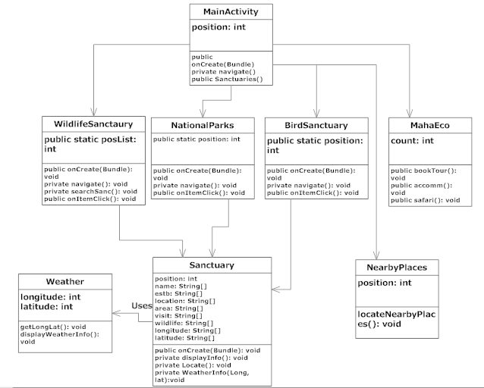

Fig. (3.1): Class diagram of MahaWild

Use Case Diagram:-

Use case diagrams are used to gather the requirements of a system including internal and external influences. These requirements are mostly design requirements. So when a system is analyzed to gather its functionalities use cases are prepared and actors are identified. Now when the initial task is complete use case diagrams are modeled to present the outside view.

So in brief, the purposes of use case diagrams can be as follows:

- Used to gather requirements of a system.
- Used to get an outside view of a system.
- Identify external and internal factors influencing the system.
- Show the interacting among the requirements are actors.

Use case diagram for MahaWild.apk is shown below:

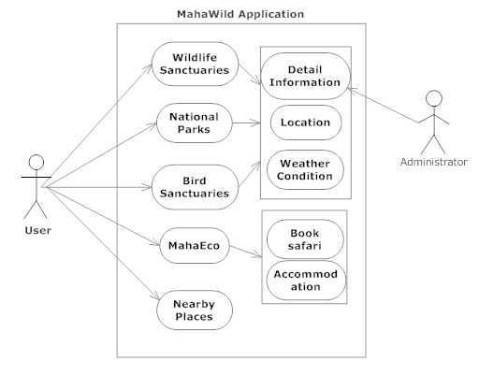

Fig. (3.2): Use Case diagram of MahaWild

Sequence Diagram:-

Class diagram do not represent the dynamic behavior of the system. That is, how the system behaves when it performs some of its functions cannot be represented by class diagrams. This is done through sequence diagrams. A sequence diagram shows the series of messages exchanged between some objects, and their temporal ordering, when objects collaborate to provide some desired system functionality. The sequence diagram is generally drawn to model the interaction between objects for a particular use case.

The sequence diagram of MahaWild.apk is shown below:-

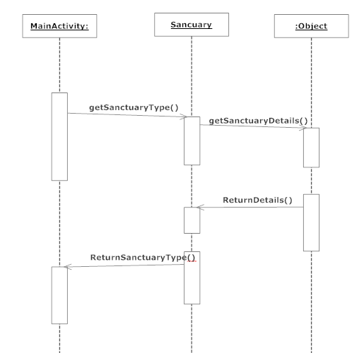

Fig. (3.3): Sequence diagram of MahaWild

- Screenshots & Results
Following are the snapshots of working application.

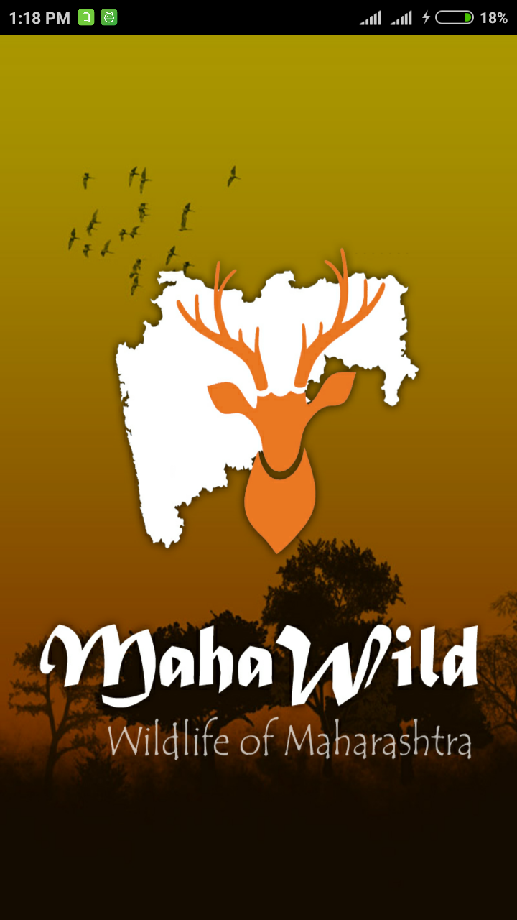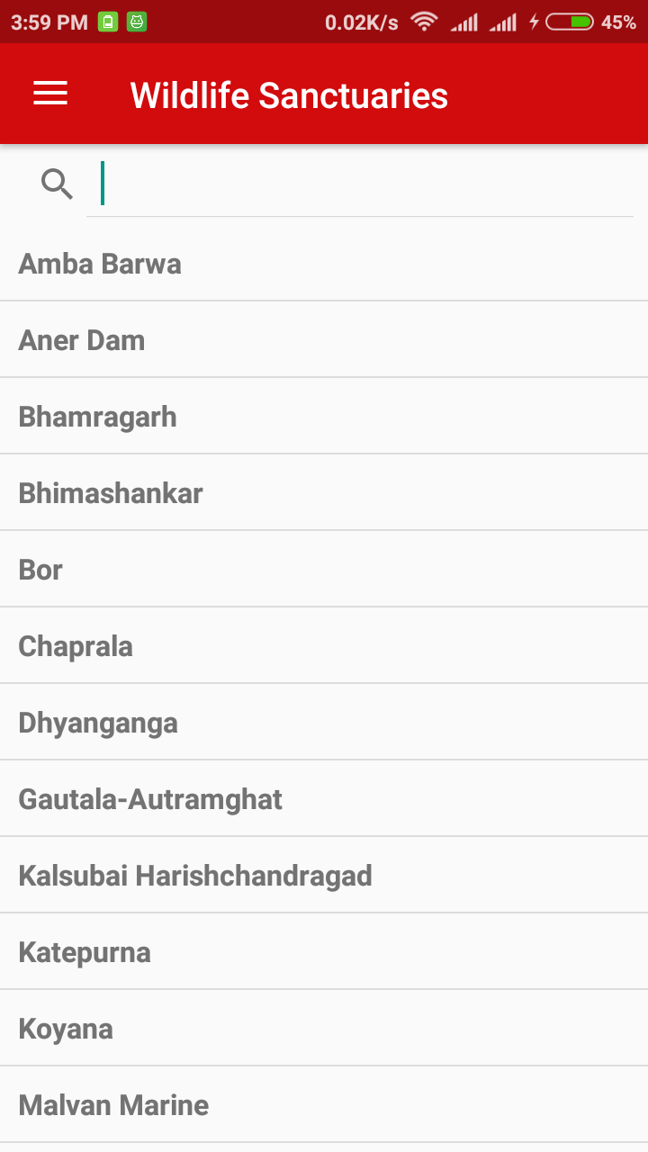
Fig. (4.1): Splash Screen Fig. (4.2): Wildlife Sanctuaries

Fig. (4.1) Shows splash screen & Fig. (4.2) Shows Main screen of MahaWild App.

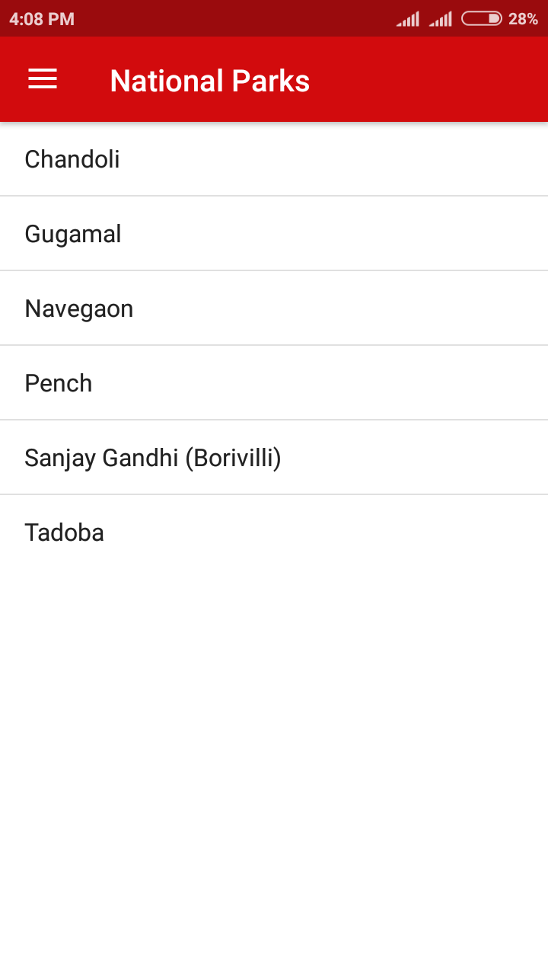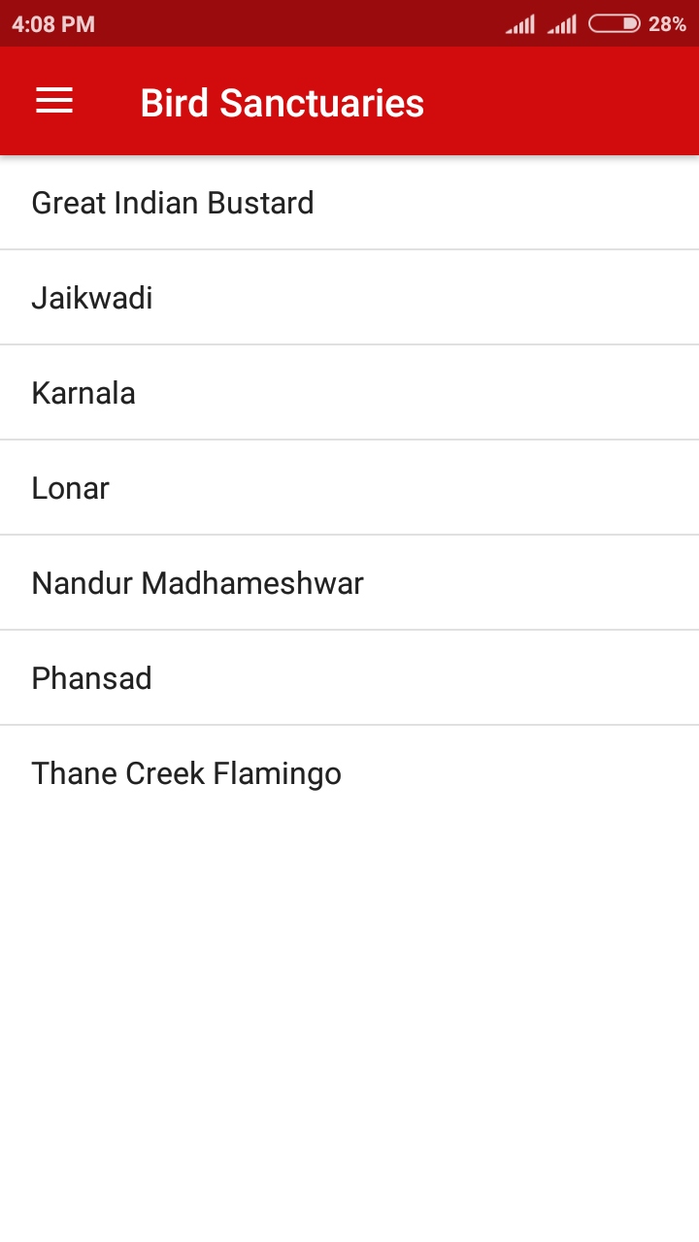
Fig. (4.3): National Parks Fig. (4.4): Bird Sanctuaries

Fig. (4.3) & (4.4) shows the National Parks & Bird sanctuaries respectively, in a list.
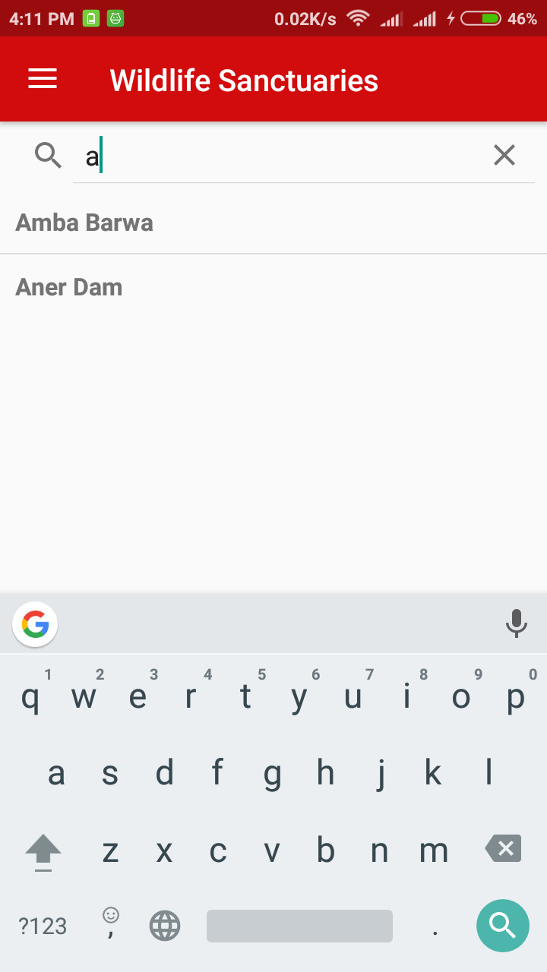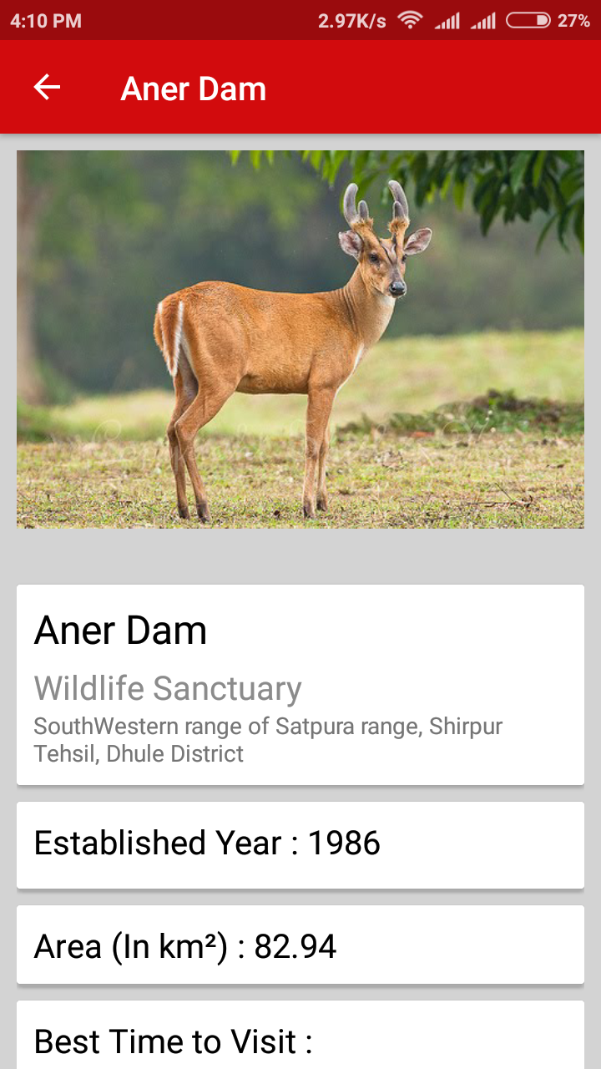
Fig. (4.5): Search a sanctuary Fig. (4.6): Selected sanctuary info.

Fig. (4.5) searchview to search a particular sanctuary & Fig. (4.6) sanctuary information.

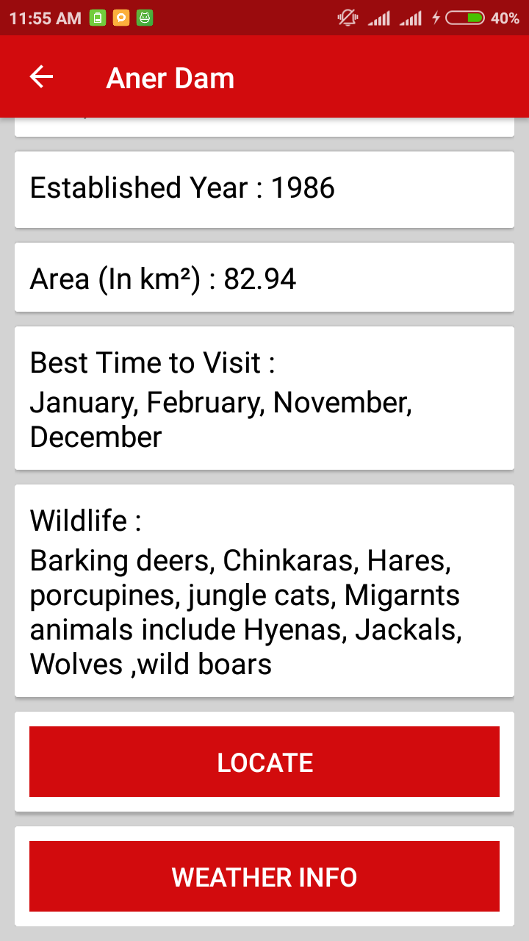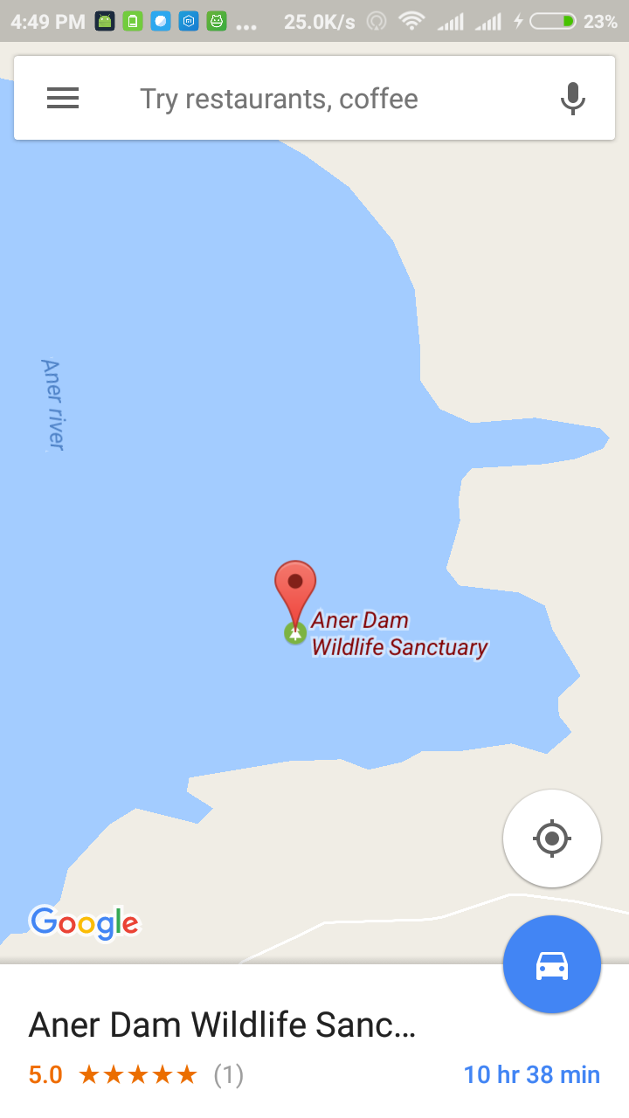
Fig. (4.7): Selected sanctuary info. Fig. (4.8): Location of sanctuary
After clicking on the “Locate” button in Fig. (4.7), the sanctuary’s exact location is shown on the Google Map as in above Fig. (4.8).
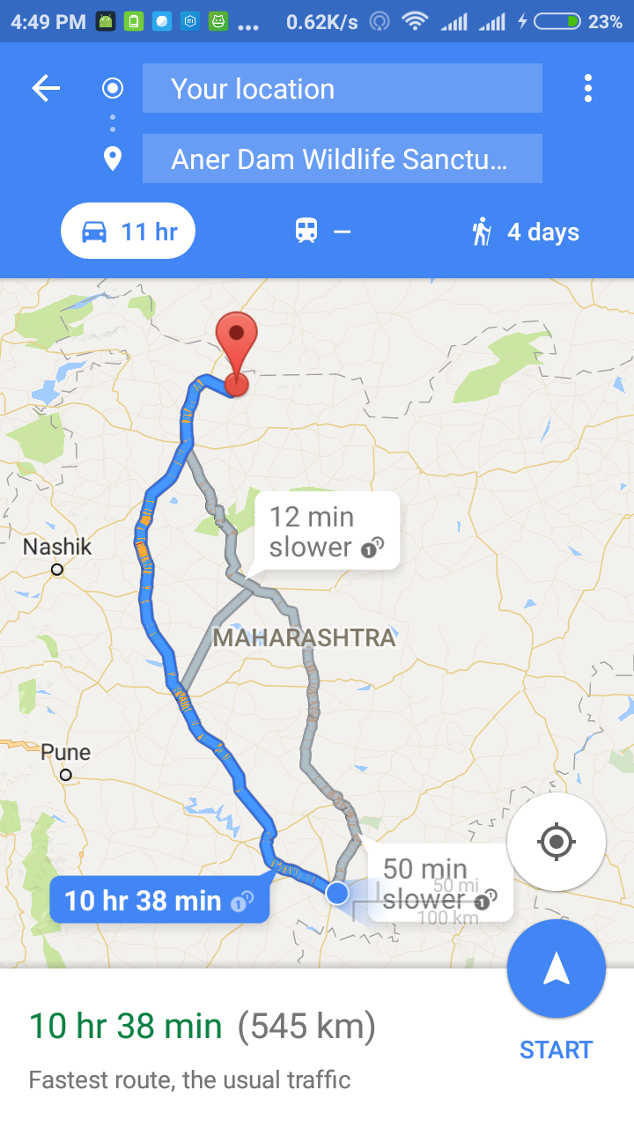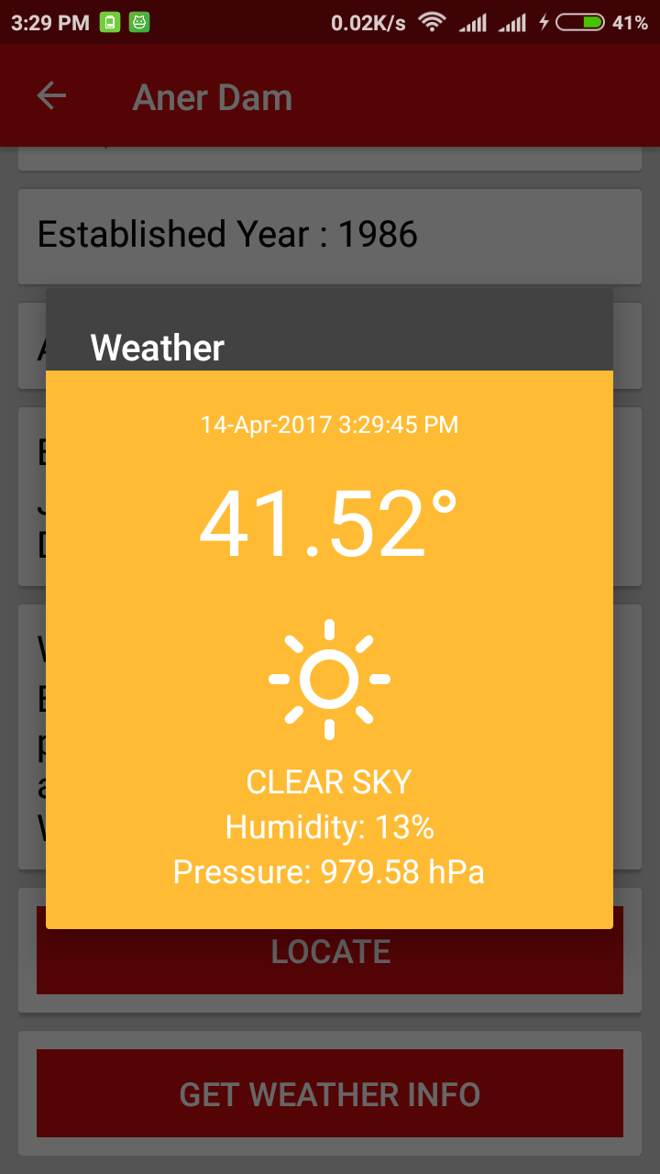
Fig. (4.9): Minimal route Fig. (4.10): Current weather info.
You can also find the minimal route from your current location by using the “Get directions” button in Fig. (4.9). Even you can get the current weather information by using the “GET WEATHER INFO” button (see Fig. (4.10)).

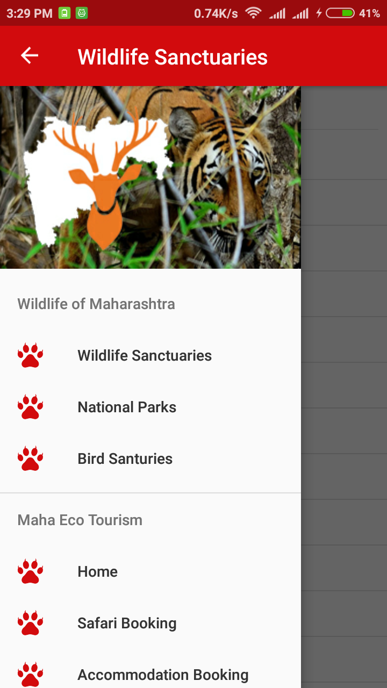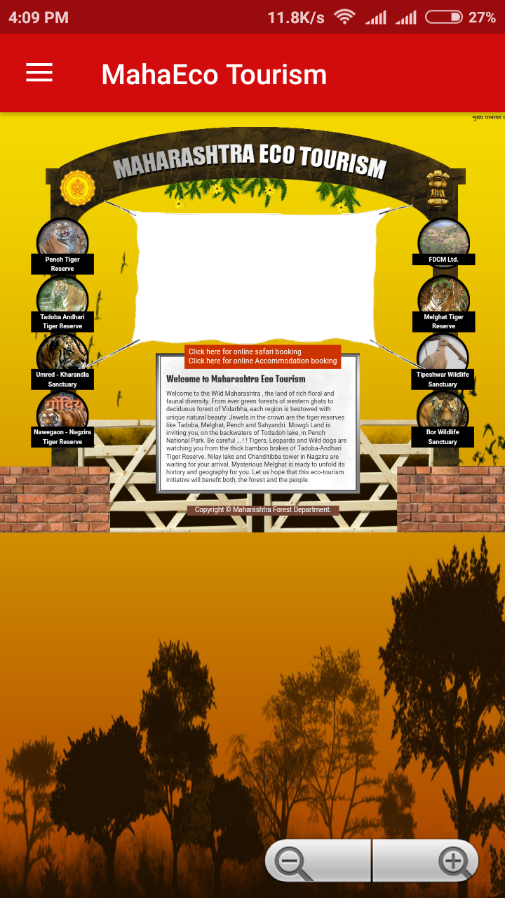
Fig. (4.11): Navigation Drawer Fig. (4.12): MahaEco Tourism Webpage
Fig. (4.11) shows the navigation drawer for quick access of any activity in the application. The Home item in navigation drawer displays a webpage of “MahaEco Tourism” (see Fig. (4.12)).

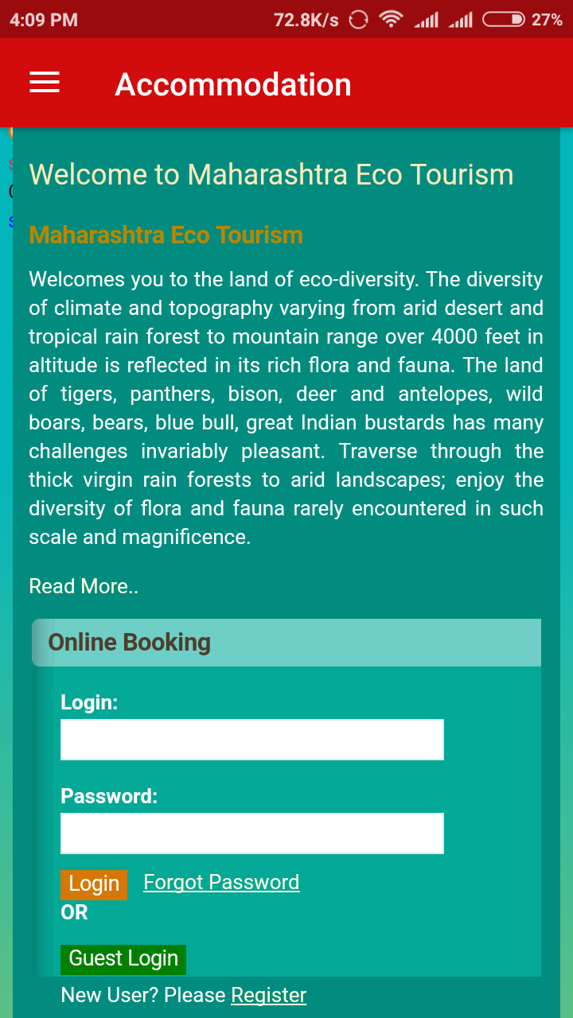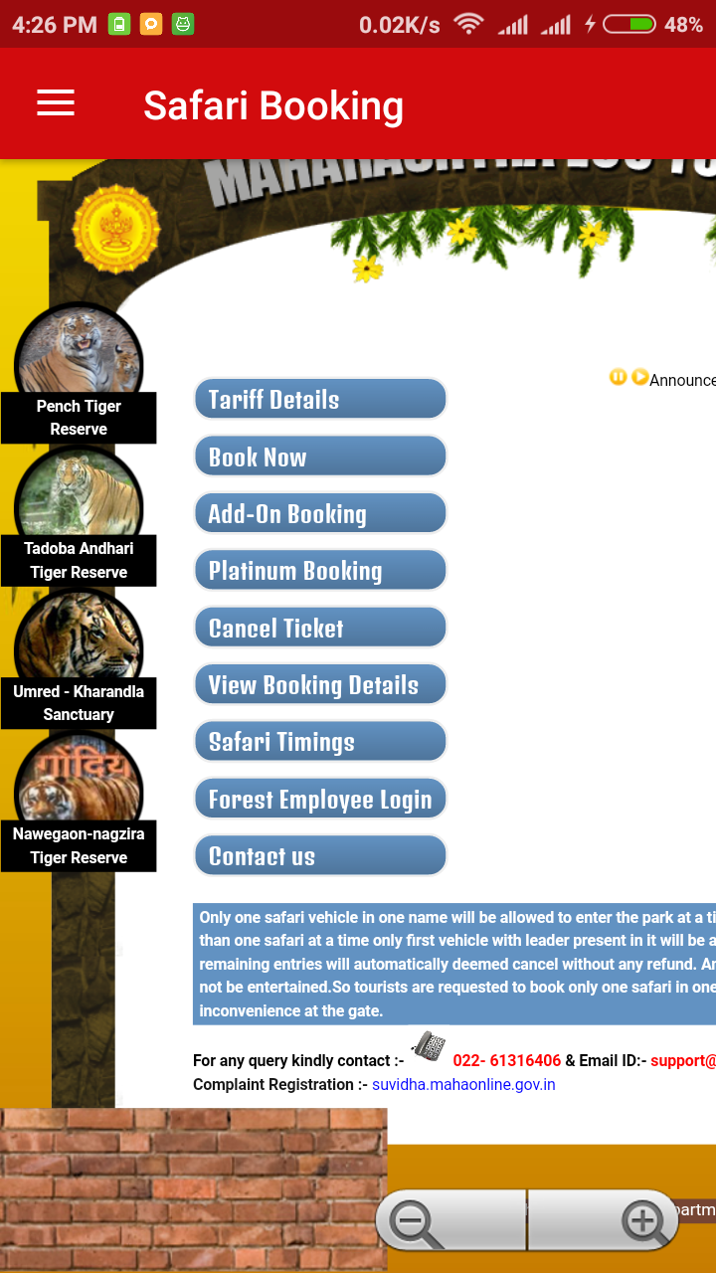
Fig. (4.13): Accommodation booking Fig. (4.14): Safari booking

Fig. (4.13) & (4.14) are for online booking of accommodation & safari.

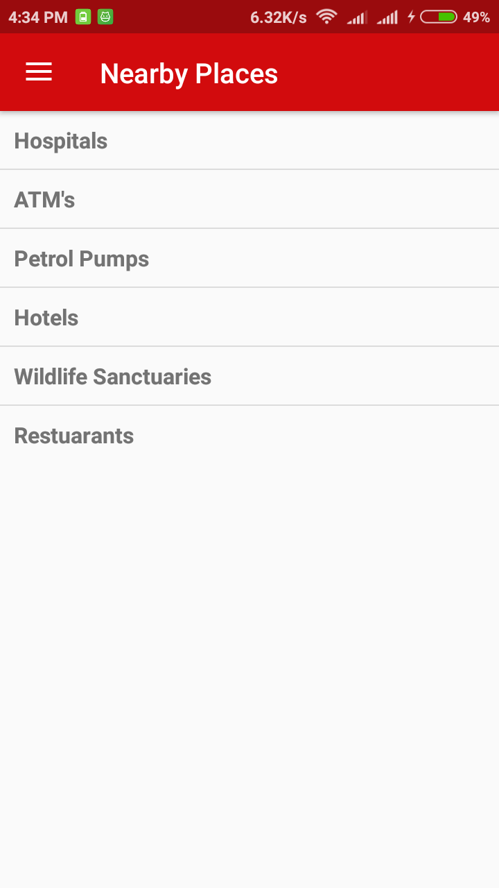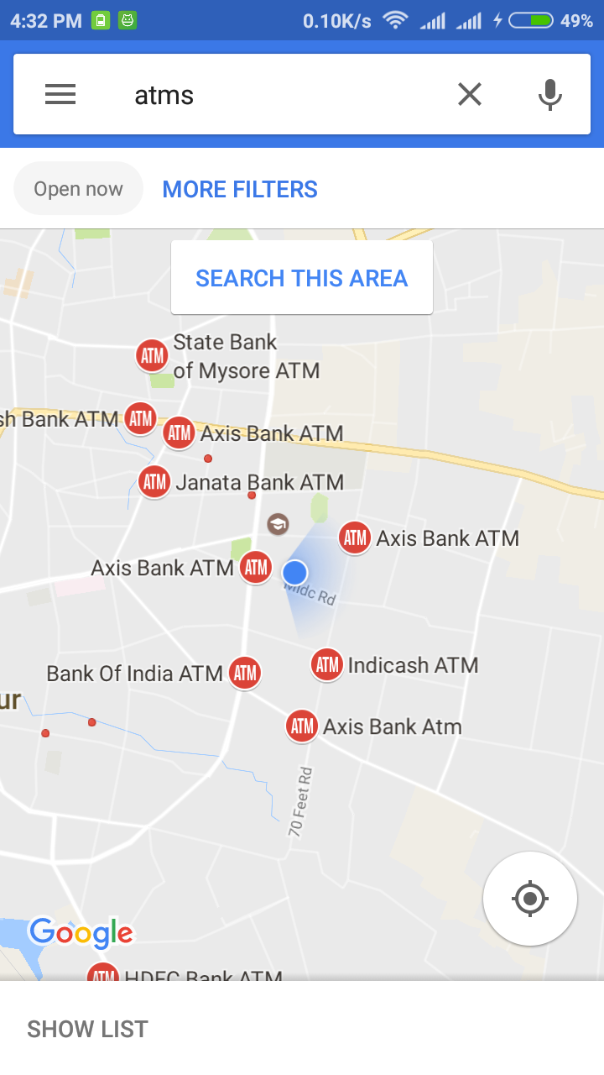
Fig. (4.15): Nearby Places Fig. (4.16): Nearby ATM’s

To locate hospitals, ATM’s, hotels, other wildlife sanctuaries, restaurants near your current location, select “Nearby Places” tab in navigation drawer. It consists of a list as in Fig. (4.15) & the nearby places are shown in Google Map (Fig. (4.16) show nearby ATM’s).

- Advantages

- The app is dynamic in the sense only one activity is used to display information of any sanctuary so that the app size is less.
- Relevant information about each sanctuary is available.
- Google Map is used to locate sanctuary, so that user can not only view exact location of sanctuary but also find the minimal route from any position.
- Nearby Places option is provided for locating the nearest hotels, hospitals, restaurants, cafes, ATM’s & other wildlife sanctuaries.
- Provided weather information of sanctuaries separately to get the current weather information of any sanctuary.
- Online booking of safari, accommodation is available.
- The MahaWild App also suggests the best time to visit any wildlife sanctuary.
- Also provided the famous wildlife animals present their so that user can visit the sanctuary based on his favorite wildlife animals.

- Disadvantages

- This application supports only on Android devices.
- Only current weather information of sanctuary is available.

- Applications

- Useful for wildlife lovers to know sanctuaries information.
- For the users who want to book the safari in a particular sanctuary in Maharashtra.
- Also useful for accommodation booking near the sanctuary.
- For locating the nearby emergency services such as ATM’s, wildlife sanctuaries, restaurants, cafes, hospitals, hotels etc.
- This App is used to get the current weather information of a particular sanctuary.

- Future scope

Currently the android application is only restricted for the Maharashtra state. Further the application will be developed for the country. Currently the android application is not completely online. Further the application will be developed as complete online so that we can provide more information about the sanctuaries including tour guide for users. This App gives current weather information. Further we can provide the weather forecast feature that will give 4 days weather information.

- Conclusion

First of all, from this project, we have learnt how to build Android Apps. In this project we analyzed the solutions currently available for the implementation of Android application for mapping the sanctuaries. In recent the users are interesting in tours at wildlife sanctuaries. So they are expecting the information of all wildlife sanctuaries to get at one platform. The App gives the attached safari & accommodation that user can book to enjoy the wildlife vacation. This App is a perfect way to spend holiday while enjoying the nature of Maharashtra. Not only we list the wildlife sanctuaries across Maharashtra, we also suggest user the best wildlife sanctuary to visit on his time of month. We made users holiday & vacation planning easy.

- References

[1] Android Application Development by tutorialspoint downloaded on Jan 05, 2017.

[2] Learn Android Studio – Build Android Apps Quickly and Effectively by Adam Gerber, Clifton Craig downloaded on Jan 05, 2017.

[3] Beginning Android 4 Application Development by Wei-Meng Lee downloaded on Jan 16, 2017.

[4] http://natureconservation.in/list-of-wildlife-sanctuaries-in-maharashtra-updated/

[5] https://developer.android.com/index.html

[6] https://accommodation.mahaonline.gov.in/Home/Index.aspx

[7] https://stackoverflow.com/

[8] https://github.com

[9] www.google.co.in/maps/

[10] https://openweathermap.org/api

